**Riphah International University Lahore, Pakistan**

|  |
| --- |
|  |

**Riphah School of Computing & Innovation**

**Semester Project**

**PROJECT PROPOSAL & PLAN**

**Event Management System**

**Project Team**

|  |  |  |  |  |
| --- | --- | --- | --- | --- |
| **Student Name** | **Student ID** | **Program** | **Contact Number** | **Email Address** |
| Daniyal Wajid | 48528 | BSSE |  | 48528@students.riphah.edu.pk |
| Uzair Hassan | 48525 | BSSE |  | 48525@students.riphah.edu.pk |

**BookMyVenue**

**Project Proposal**

## Executive Summary

Book My Venue is an online platform designed to streamline the booking and management of event halls, catering, and decoration services. The system facilitates hall owners in registering their venues, listing available services such as catering, decorations, and event-related accommodations. Simultaneously, users can browse available halls, compare services, and book them according to their requirements. The system aims to bridge the gap between event organizers and service providers, ensuring seamless event planning and execution. It enhances efficiency, reduces manual effort, and provides a centralized platform for event management.

## 1. Introduction

Event planning is a complex task that involves multiple service providers, including hall owners, decorators, and caterers. Traditionally, customers must physically visit multiple venues and negotiate services, which is time-consuming and inefficient. This project proposes a digital platform where users can explore, compare, and book event-related services online. The solution is designed for individuals and businesses seeking a seamless event management experience.

## 2. Existing System / Competitive Analysis

In the **Pakistani market**, the event industry is growing, with an increasing demand for digital solutions. Currently, event management is highly reliant on personal contacts and referrals. Some local platforms, like **VenueHub.pk** and **ThePakEvents.pk**, offer wedding planning services, but there is no unified system catering to corporate events, private parties, and weddings collectively. Our system will address this gap by providing an all-in-one booking platform.

| **Competitor** | **Features** | **Strengths** | **Weaknesses** |
| --- | --- | --- | --- |
| **VenueHub.pk** | Venue listing and booking | Dedicated venue booking system, localized focus | No catering or decoration services included |
| **Bookirea** | Online hall and event space booking | Offers corporate and private event bookings | Service availability is limited in some cities |
| **ThePakEvent.com** | Event planning, venue booking, catering services | Covers multiple event types beyond weddings | Limited customization options for event packages |
| **Eventsbooking.pk** | Hall and venue booking for weddings and corporate events | Strong presence in major cities | Less focus on smaller-scale events |
| **Evento.com.pk** | Complete event management, vendor listings | All-in-one event solution covering multiple services | Relatively new in the market, needs more vendor partnerships |

## 3. Problem Statement

Event planning involves multiple stakeholders, making it difficult for users to coordinate bookings for halls, catering, and decorations. This leads to inefficiencies, miscommunication, and potential scheduling conflicts. Additionally, hall owners struggle to reach a broader audience and manage their bookings efficiently. There is a need for a centralized online platform that simplifies event planning and service management.

## 4. Proposed Solution

The **Event Management System** provides an online platform where hall owners can register their venues, list available services (e.g., catering, decorations), and manage bookings. Users can browse event halls, check availability, compare prices, and book services based on their requirements. The system will feature:

* A user-friendly dashboard for hall owners to manage bookings and services.
* A search and filter option for users to find halls based on location, price, and availability.
* Secure online booking and payment processing.
* Customer reviews and ratings for services.
* Automated booking confirmations and notifications.

## 5. Scope of the Project

### **Included Features:**

1. **Hall Registration:** Hall owners can register their venues, add details, pricing, and available services.
2. **Service Listings:** Vendors can list catering, decoration, and other event-related services.
3. **User Booking:** Customers can browse, compare, and book services.
4. **Payment System:** Secure online payment and booking confirmation.
5. **User Reviews & Ratings:** Customers can provide feedback on services.
6. **Admin Panel:** A control panel for managing users, bookings, and services.

### **Excluded Features:**

1. **On-site Event Management:** The system does not handle physical event coordination.
2. **Live Streaming Services:** No direct support for live event streaming.
3. **Third-party Vendor Integration:** Limited to internal service providers.

## 6. Technology Stack

The **Event Management System** will be developed using the **MERN (MongoDB, Express.js, React.js, Node.js) stack**:

* **MongoDB:** NoSQL database to store event details, user data, and booking information.
* **Express.js:** Backend framework to handle server-side logic and API requests.
* **React.js:** Frontend library for a dynamic and responsive user interface.
* **Node.js:** Runtime environment for backend development.
* **JWT Authentication:** Secure login and user authentication.
* **Stripe:** For secure online payments.

## 7. SWOT Analysis

### **Strengths:**

1. Comprehensive one-stop solution for event planning.
2. User-friendly interface for both service providers and customers.
3. Secure and efficient online payment system.
4. High potential for automation, reducing manual effort.
5. Scalability to include additional services in the future.

### **Weaknesses:**

1. Initial marketing effort required to attract vendors and users.
2. Dependence on hall owners and service providers to keep information updated.
3. Possible resistance from traditional service providers unfamiliar with digital platforms.
4. Need for continuous platform maintenance and security updates.

### **Opportunities:**

1. Expansion to include additional event-related services (photography, entertainment, etc.).
2. Potential partnerships with event planners and vendors.
3. Integration with social media for wider reach.
4. Growing internet penetration and smartphone usage in Pakistan support digital adoption.
5. Potential for corporate events, exhibitions, and conferences alongside weddings.

### **Threats:**

1. Competition from established event management platforms.
2. Resistance from traditional event planners reluctant to switch to digital platforms.
3. Security concerns related to online transactions.
4. Unpredictable government regulations related to e-commerce and digital transactions in Pakistan.
5. Economic fluctuations affecting user spending on events.
   1. **System Features**

# User Registration

* + - 1. **Description and Priority**

Allows users to create an account by providing basic personal details.

**Priority:** High

# Stimulus/Response Sequences

* + - * + **User Action:** Opens registration page and submits form.
        + **System Response:** Validates input, creates account, and redirects to login page.

# Functional Requirements

* + - * + **REQ-SF1-1:** The system shall allow users to register with name, email, and password.
        + **REQ-SF1-2:** The system shall validate if email is already registered.
        + **REQ-SF1-3:** The system shall send confirmation or welcome notification after successful registration.

# Business Owner Registration

* + - 1. **Description and Priority**

Allows business owners to register their business to offer services.

**Priority:** High

# Stimulus/Response Sequences

* + - * + **Business Owner Action:** Fills out business registration form.
        + **System Response:** Validates data, stores business profile, and notifies admin for verification.

# Functional Requirements

* + - * + **REQ-SF2-1:** The system shall accept business type, name, and details during registration.
        + **REQ-SF2-2:** The system shall notify admin for verification post-registration.
        + **REQ-SF2-3:** The system shall restrict unverified businesses from being visible to users.

# Event Booking

* + - 1. **Description and Priority**

Users can book event services including venue, catering, and decor.

**Priority:** High

# Stimulus/Response Sequences

* + - * + **User Action:** Selects services and confirms booking with payment.
        + **System Response:** Confirms availability, processes payment, and sends booking confirmation.

# Functional Requirements

* + - * + **REQ-SF3-1:** The system shall allow multi-service booking (venue, decor, catering).
        + **REQ-SF3-2:** The system shall check service availability before confirming.
        + **REQ-SF3-3:** The system shall generate and send booking confirmation.

# Payment Integration

* + - 1. **Description and Priority**

Facilitates secure online payment processing.

**Priority:** High

# Stimulus/Response Sequences

* + - * + **User Action:** Proceeds to checkout and makes payment.
        + **System Response:** Validates payment, confirms transaction, and generates invoice.

# Functional Requirements

* + - * + **REQ-SF4-1:** The system shall support credit/debit cards and online payment methods.
        + **REQ-SF4-2:** The system shall notify users of payment status.
        + **REQ-SF4-3:** The system shall handle failed or declined transactions gracefully.

# Admin Panel

* + - 1. **Description and Priority**

Admin can monitor and manage users, business owners, and reports.

**Priority:** High

# Stimulus/Response Sequences

* + - * + **Admin Action:** Access dashboard, approve business owner, delete user.
        + **System Response:** Performs action and updates data accordingly.

# Functional Requirements

* + - * + **REQ-SF5-1:** The system shall allow admin to approve or block business owners.
        + **REQ-SF5-2:** The system shall generate reports of bookings, users, and earnings.
        + **REQ-SF5-3:** The system shall allow admin to manage user accounts.

# Notification System

* + - 1. **Description and Priority**

Sends automated alerts to users and business owners.

**Priority:** Medium

# Stimulus/Response Sequences

* + - * + **System Triggers:** After bookings, cancellations, or updates.
        + **System Response:** Sends notification via in-app or email.

# Functional Requirements

* + - * + **REQ-SF6-1:** The system shall notify users after booking confirmation.
        + **REQ-SF6-2:** The system shall notify business owners of new bookings.
        + **REQ-SF6-3:** The system shall send event reminders to users.

# Other Nonfunctional Requirements

* + 1. **Performance Requirements**
       - The system shall respond to user actions within 2 seconds under normal conditions.
       - Booking processing should not exceed 5 seconds.

# Safety Requirements

* + - * Sensitive data such as payment info must never be stored in plain text.
      * Booking data must be backed up daily to prevent loss.

# Security Requirements

* + - * All user passwords must be hashed using a secure algorithm.
      * Business owners must be verified by admin before activation.
      * System must support role-based access control (user, owner, admin).

# Software Quality Attributes

* + - * **Usability:** System should be user-friendly and mobile-responsive.
      * **Maintainability:** Modular design to allow easy updates.
      * **Reliability:** System uptime must be 99.5% or higher.
      * **Scalability:** Should support growth in users and service types.

# Competitive Analysis / Existing Applications

|  |  |  |  |
| --- | --- | --- | --- |
| **Feature / App** | **Bookeria** | **BookEvent** | **BookMyVenue** |
| **2 Factor Authentication** | ✔ | ❌ | ✔ |
| **360 deg Images** | ❌ | ❌ | ✔ |
| **Multi-Service Booking (Hall + Food)** | ❌ | ❌ | ✔ |
| **Discounts and Offers** | ❌ | ❌ | ✔ |
| **Payment Integration** | ✔ | ✔ | ✔ |
| **Real-Time Availability** | ❌ | ❌ | ✔ |
| **Notifications** | ✔ | ✔ | ✔ |

* 1. **Technology Stack:**
     + **Frontend:** React.JS, HTML, CSS
     + **Backend:** Node.js
     + **Database:** MongoDB
     + **Authentication:** Google Auth
     + **Payment Gateway:** Stripe / PayPal

**Architecture Diagram:**

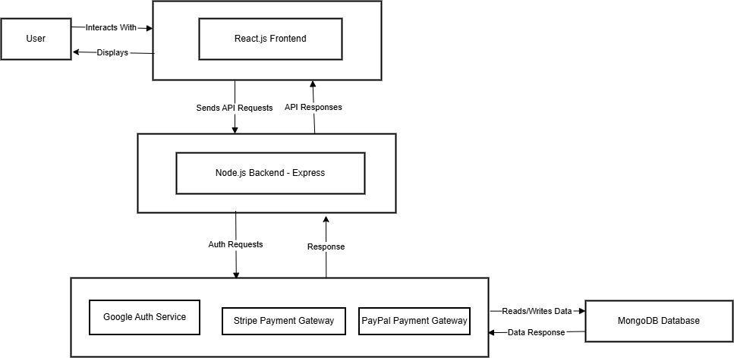

**SDLC Model:**

* **Model:** Agile
* **Why:** Allows iterative development with regular feedback and adjustments.
* **Stages:**
  + Planning & Requirement Gathering
  + Design
  + Development (sprints using MERN Stack)
  + Testing & Quality Assurance
  + Deployment
  + Feedback & Maintenance

**Gantt Chart:**

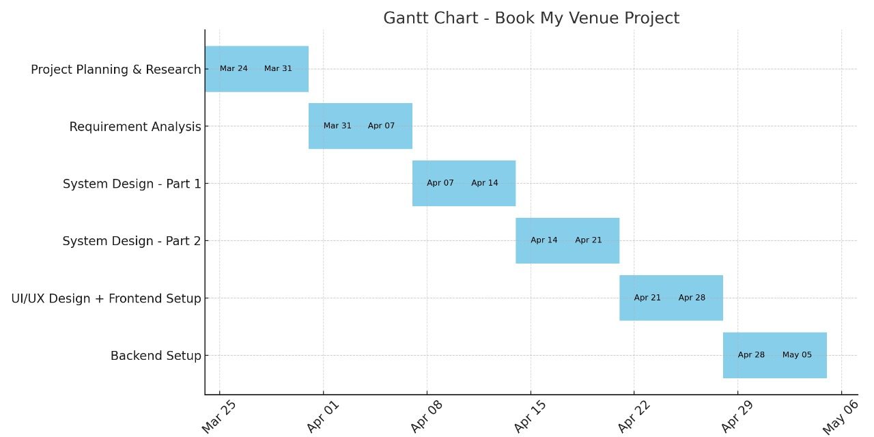

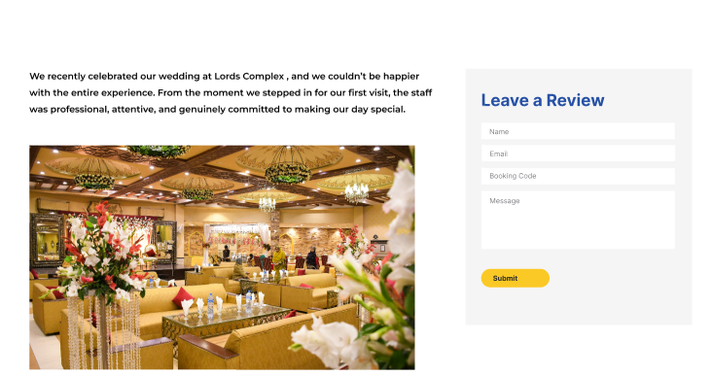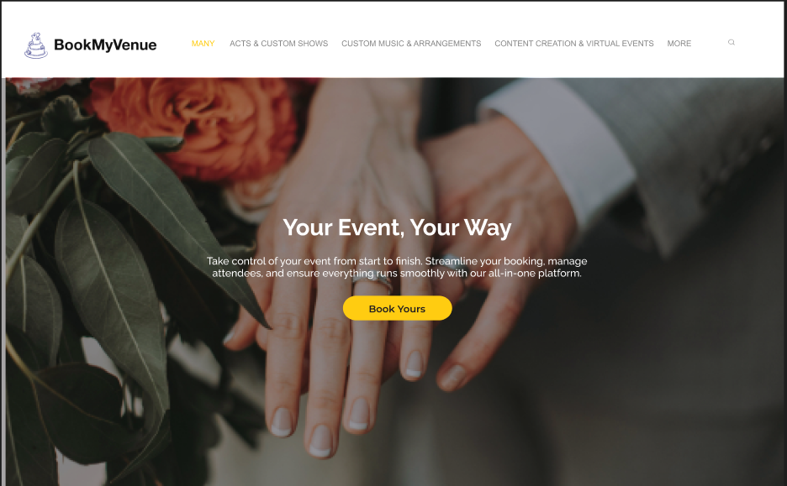**Mockups:**

### **The Business Opportunity**

Event planning in Pakistan remains highly fragmented and manual, relying heavily on personal networks, physical visits, and word-of-mouth referrals. This leads to scheduling conflicts, service mismatches, and limited visibility for venue owners and service providers. BookMyVenue solves this by offering a centralized digital platform that streamlines booking of event halls, catering, and decorations—all in one place.

### **Company Description**

BookMyVenue is a tech-driven platform that simplifies event planning by connecting users with verified venues and service providers. Our platform allows users to explore, compare, and book venues, catering, and decoration services seamlessly. Simultaneously, it empowers service providers by offering tools to manage bookings and showcase their offerings to a larger digital audience.

### **Industry Analysis**

The Pakistani event management industry is growing rapidly, fueled by increasing urbanization and tech adoption. Competitors like VenueHub.pk and Bookirea offer partial services but lack integration of multiple service types in one system. The success factors in this industry include a user-friendly interface, vendor reliability, real-time availability, and secure payment gateways.

### **Implementation Timeline**

* **Week 1: Project Planning & Research**  
  Conduct market research, competitor analysis, and finalize business goals and platform objectives.
* **Week 2: Requirement Analysis**  
  Gather functional and non-functional requirements; define user roles, system architecture, and scope.
* **Week 3: System Design – Phase 1**  
  Initial database modeling, backend structure planning, and API flow setup.
* **Week 4: System Design – Phase 2**  
  Complete design of user flows, admin panel logic, and third-party service integration (e.g., Stripe).
* **Week 5: UI/UX Design & Frontend Development**  
  Develop a responsive, user-friendly interface using React.js with a focus on mobile compatibility.
* **Week 6: Backend Setup & Integration**  
  Setup Node.js backend, connect MongoDB, implement authentication, and integrate payment gateway.

### **Financial Summary**

* **Fixed Costs:**
  + Server hosting and infrastructure
  + Salaries for dev & operations team
  + Marketing & branding
* **Variable Costs:**
  + Transactional fees
  + Customer support operations
  + Commission to vendors (if applicable)
* **Revenue Streams:**
  + Commission on each booking
  + Premium listings and ads for vendors
  + Subscription plans for high-traffic venue owners
* **Sales Goals:**
  + Year 1: 1000+ bookings/month from Lahore
  + Year 3: Expand to 5 major cities and reach 10,000+ monthly users

### **Team**

* **Daniyal Wajid** – Tech Lead & Backend Developer (BSSE, Riphah)
* **Uzair Hassan** – Product Manager & Frontend Developer (BSSE, Riphah)

Both team members bring strong technical backgrounds in full-stack web development, project management, and are deeply familiar with the local market needs.

### **Target Market**

Our primary users are:

* Individuals planning weddings and parties
* Corporates organizing conferences, seminars, and exhibitions
* Event planners looking to coordinate multiple services efficiently

### **Buyer Personas**

• **The Perfectionist**  
Seeks flawless events with reliable vendors and seamless coordination.

• **The Corporate Planner**  
Values professionalism, punctuality, and strict budget control for business events.

• **The Budget-Conscious**  
Prioritizes cost-effective solutions and user reviews before making decisions.

### **Marketing Plan**

We will focus on digital-first marketing using:

* **Social Media Ads (Instagram, Facebook, TikTok)** targeting event hashtags and geo-location
* **Google Ads** for venue-related searches
* **Influencer Collaborations** with event planners and vloggers
* **Referral Discounts** for user acquisition and retention

### **Funding Required**

We are seeking **PKR 2.5 million** (~USD 9,000) for:

* Development (frontend/backend and QA testing)
* Marketing campaigns for launch
* Vendor onboarding and logistics
* Legal and administrative setup

### **Financial Plan**

### **Fixed Costs (Annual)**

Fixed costs are those that remain consistent throughout the year regardless of how much the service is used. These include expenses related to infrastructure, salaries, and marketing efforts.

| **Category** | **Details** | **Annual Cost (PKR)** |
| --- | --- | --- |
| **Server Hosting & Infrastructure** | Cloud services, database storage, server management, backup, and scaling | 600,000 |
| **Development Team Salaries** | Full-stack developers, UI/UX designers, QA testers | 1,500,000 |
| **Operations Team Salaries** | Customer support, platform maintenance, etc. | 800,000 |
| **Marketing & Branding** | Digital marketing (ads, influencer collaborations, SEO, etc.) | 1,000,000 |
| **Office Rent & Utilities** | Physical office space and utilities | 500,000 |
| **Legal & Administrative Setup** | Business registration, legal fees, and compliance | 200,000 |

**Total Fixed Costs**: **PKR 4,600,000**

### **Variable Costs (Annual)**

Variable costs fluctuate based on usage, volume, and transactional activity. These costs are incurred based on the number of bookings and users on the platform.

| **Category** | **Details** | **Annual Cost (PKR)** |
| --- | --- | --- |
| **Payment Gateway Fees** | Stripe/PayPal charges per transaction (2-3% per payment) | 250,000 |
| **Customer Support Operations** | Outsourced or internal support for users and vendors | 300,000 |
| **Commission to Vendors** | 10% commission per transaction (paid to service providers) | 1,200,000 |
| **Transaction Fees** | Bank fees for transactions (if applicable) | 100,000 |

**Total Variable Costs**: **PKR 1,850,000**

### **Revenue Streams**

The primary sources of revenue will come from commissions on bookings, premium listings for vendors, and subscription plans for high-traffic venue owners.

#### **Commission on Each Booking**

* **Booking Revenue per Transaction**: 10% commission on each event booking
* **Average Booking Value (per event)**: PKR 50,000
* **Estimated Monthly Bookings**: 1,000 bookings (year 1)

Revenue from bookings:

Monthly Revenue=1,000×50,000×0.10=5,000,000PKR/month

**Annual Revenue from Commissions**: **PKR 60,000,000**

#### **Premium Listings and Ads for Vendors**

* **Revenue per Vendor**: PKR 5,000 per month for a premium listing
* **Estimated Vendors**: 200 vendors (year 1)

Revenue from listings:

Monthly Revenue=200×5,000=1,000,000PKR/month

**Annual Revenue from Premium Listings**: **PKR 12,000,000**

#### **Subscription Plans for High-Traffic Venue Owners**

* **Subscription Fee per Venue**: PKR 15,000/month
* **Estimated High-Traffic Venues**: 50 venues (year 1)

Revenue from subscriptions:

Monthly Revenue=50×15,000=750,000PKR/month

**Annual Revenue from Subscriptions**: **PKR 9,000,000**

### **Total Revenue (Year 1)**

| **Revenue Source** | **Annual Revenue (PKR)** |
| --- | --- |
| **Commission on Bookings** | 60,000,000 |
| **Premium Listings & Ads** | 12,000,000 |
| **Subscription Plans** | 9,000,000 |
| **Total Annual Revenue** | **81,000,000** |

### **Profit & Loss Summary (Year 1)**

| **Category** | **Amount (PKR)** |
| --- | --- |
| **Total Annual Revenue** | 81,000,000 |
| **Total Fixed Costs** | 4,600,000 |
| **Total Variable Costs** | 1,850,000 |
| **Total Costs (Fixed + Variable)** | 6,450,000 |
| **Net Profit (Revenue - Costs)** | **74,550,000** |

**Net Profit Margin** = Net Profit/Revenue * 100 = 74,550,000​/81,000,000​ * 100 = 92%

**Cash Flow Summary (Year 1)**

| **Month** | **Revenue (PKR)** | **Fixed Costs (PKR)** | **Variable Costs (PKR)** | **Net Cash Flow (PKR)** |
| --- | --- | --- | --- | --- |
| **Month 1-3** | 20,250,000 | 1,150,000 | 462,500 | 18,637,500 |
| **Month 4-6** | 20,250,000 | 1,150,000 | 462,500 | 18,637,500 |
| **Month 7-9** | 20,250,000 | 1,150,000 | 462,500 | 18,637,500 |
| **Month 10-12** | 20,250,000 | 1,150,000 | 462,500 | 18,637,500 |

**Total Cash Flow Year 1**: **PKR 74,550,000**

### **Break-Even Analysis**

To calculate the break-even point, we need to identify when total revenue exceeds total costs (fixed and variable). Given the current structure:

Break-Even Point= Total Fixed Costs​ / (Revenue per Unit−Variable Cost per Unit)

Where:

* **Fixed Costs** = 4,600,000 PKR
* **Revenue per Booking** = 5,000 PKR (10% of average booking value)
* **Variable Cost per Booking** = 500 PKR (including commission, payment gateway fees)

Thus, the break-even point in terms of bookings:

Break-Even Bookings= 4,600,000/(5,000−500) = 4,600,000 / 4,500 = 1,022 bookings/month​​

**Break-even point**: Approximately **1,022 bookings per month**.

### **Funding and Investment Requirements**

**Total Funding Required**: PKR 2.5 million (~USD 9,000)

This investment will be allocated as follows:

* **Platform Development** (Frontend/Backend): 50% of total funds
* **Marketing & Vendor Onboarding**: 30% of total funds
* **Legal & Administrative Setup**: 20% of total funds

This capital will ensure the platform can launch and scale smoothly while addressing initial development and marketing needs.

With an estimated **net profit of PKR 74,550,000** in Year 1, the business is poised for profitability.

**Risk Analysis**

### **Operational Risks**

**Technology Failures**  
Given that BookMyVenue is built on a technology stack (MERN), there’s always a risk of system outages, bugs, or slowdowns. A major technical failure could disrupt the user experience, causing dissatisfaction and loss of customers.

**Mitigation Strategy**: Regular maintenance and updates, along with a skilled IT support team, will be necessary. Implementing cloud-based solutions with high availability and backup systems can minimize downtime.

**Scalability Challenges**  
As the platform expands to other cities or scales in terms of users and vendors, the system might face difficulties handling large volumes of data and users. Overloading the platform could affect performance.

**Mitigation Strategy**: Focus on building a highly scalable infrastructure from the beginning, using cloud services (e.g., AWS, Google Cloud) that can scale with the growing demand. Employ database optimization and load balancing techniques.

**Data Security**  
The platform will deal with sensitive data, such as personal details and payment information. There is always a risk of data breaches or security vulnerabilities that could damage the reputation of the business and violate regulations.  
**Mitigation Strategy**: Implement best practices for data encryption, regular security audits, and use of secure payment gateways (Stripe, PayPal). Store passwords securely using strong hashing algorithms and implement multi-factor authentication (MFA).

**Service Provider Reliability**  
If venue owners, caterers, decorators, or other vendors listed on the platform fail to deliver quality service or their operations are not reliable, it will affect user satisfaction and the platform’s reputation.

**Mitigation Strategy**: Vet vendors carefully before listing them. Regularly collect customer feedback and reviews to monitor vendor performance. Provide incentives for high-rated vendors and remove low performers.

### **Market and External Risks**

**Competition**  
While the market is growing, there are established competitors in the event management space like VenueHub.pk, Bookirea, and others. If these competitors innovate faster or have stronger marketing campaigns, BookMyVenue might lose market share.  
**Mitigation Strategy**: Differentiate the platform by offering superior features (e.g., multi-service booking, real-time availability), building a loyal customer base through excellent service, and offering attractive discounts and promotions.

**Market Adoption**  
Despite increasing internet penetration in Pakistan, there might still be resistance to using a digital platform for event planning, especially from traditional event planners and venue owners who prefer word-of-mouth referrals.  
**Mitigation Strategy**: Offer educational content, webinars, and workshops to onboard traditional vendors. Provide incentives for early adoption, such as reduced commission rates or free listings for the first few months.

**Economic Instability**  
Pakistan’s economy can experience fluctuations due to factors like inflation, currency devaluation, or political instability, affecting customers’ disposable income. This could lead to reduced spending on non-essential services like event planning.  
**Mitigation Strategy**: Diversify the target market by focusing not only on high-end events but also on budget-conscious customers. Consider offering tiered pricing to cater to a broader range of users.

**Government Regulations and Legal Risks**  
Changes in government regulations or taxes on e-commerce businesses could impact the operational costs of the platform. Similarly, issues related to data protection or digital payments could arise as laws evolve.  
**Mitigation Strategy**: Keep track of relevant regulatory changes and maintain legal counsel to ensure compliance. Set up a proactive approach to handle changes in the digital payments ecosystem or new e-commerce taxes.

### **Financial Risks**

**Cash Flow Issues**  
While the platform’s revenue is expected to grow over time, initial revenue might be slower than anticipated due to lower-than-expected vendor sign-ups or booking volumes. This can cause liquidity issues, especially if operational costs are high.  
**Mitigation Strategy**: Secure initial funding for operating expenses and keep track of cash flow on a monthly basis. Implement a phased marketing and vendor onboarding strategy to balance expenditures with incoming revenue.

**Vendor Payment Delays**  
If vendors delay payments or have issues with receiving funds on time, this could create a negative financial cycle, leading to operational delays or customer dissatisfaction.  
**Mitigation Strategy**: Use a reliable payment gateway and create clear terms for vendor payment schedules. Ensure contracts and agreements are in place to protect both the platform and its vendors.

### **User and Customer Risks**

**Customer Dissatisfaction**  
If customers have a poor experience with the platform (e.g., difficulties in booking, poor-quality services, delayed event planning), it can lead to negative reviews, customer churn, and loss of business.  
**Mitigation Strategy**: Offer 24/7 customer support, implement an easy-to-use interface, and regularly collect feedback to improve the platform. Have a system in place for quickly resolving complaints and issues.

**Fraudulent Activities**  
There is a potential risk of fraudulent transactions or scams, either from users or vendors. This could damage the platform’s trustworthiness and reputation.  
**Mitigation Strategy**: Implement strict verification processes for vendors, use secure payment systems to prevent fraud, and monitor transactions for suspicious activity. Offer guarantees or customer protection programs to boost trust.

### 5. **Operational and Human Resource Risks**

**Team Turnover**  
High turnover in the development team or operations could disrupt the development of new features, maintenance, and overall platform growth. Losing key team members can delay progress and affect productivity.  
**Mitigation Strategy**: Offer competitive compensation and professional development opportunities to retain talent. Develop a knowledge-sharing culture and keep documentation up-to-date to ensure smooth transitions.

**Vendor Dependency**  
The platform’s success is dependent on vendors consistently listing their services and keeping their information up-to-date. If vendors stop using the platform, it could reduce the variety of services available, leading to a drop in user engagement.  
**Mitigation Strategy**: Build long-term relationships with vendors, offering them marketing and promotional support. Keep vendors engaged through incentives, loyalty programs, and performance-based rewards.